

**2014 Noé International Team**

***“Building for the long run!”***

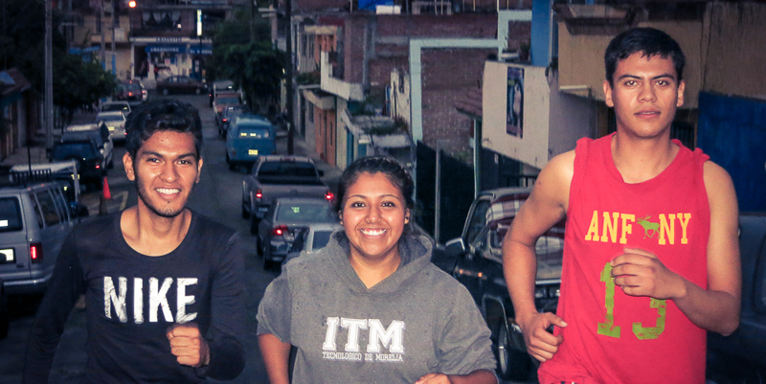

**Purpose:**

* To raise $50,000 while getting into the best shape of our lives (or at least pretty good shape for someone our age).
* To help the NOE Center in Morelia build their own facility with a matching grant from the Mexican government. **Run for a Reason!**

**October 5, 2014**

***Noé International is a faith based non-profit public Charity that supports and operates the NOE Center in Morelia, Mexico; a safe place in a low income neighborhood where children are given educational opportunities through a number of life-changing before and after school programs.***

**Check out the incredible work going on at the NOE Center in Morelia, Mexico:**

**Website**: [www.noeinternational.com](http://www.noeinternational.com)

**Facebook**: 

[www.facebook.com/noe.intl](http://www.facebook.com/noe.intl)

**More Info on the Portland Marathon at:**

[www.portlandmarathon.org](http://www.portlandmarathon.org)

**Tax Deduction:**

All gifts are tax-deductible.

Receipts will be sent to all sponsors.

Non-profit Tax ID: 93-0983604

**Noé Int’l is an Officia Charity of the Portland Marathon**

**Become a fundraising member of Team Noé and earn a complimentary entry into the event of your choice! Noé International will provide you with the tools you need to get sponsors.**

**FOR MORE INFO PLEASE WRITE US:**

[**info@noeinternational.com**](mailto:info@noeinternational.com?subject=Portland%20Marathon)

**Please include your name, phone, email and the event you are interested in:**

* **Full Marathon Run/Walk**
* **Half Marathon Run/Walk**

***The only way to get into the Half Marathon now is by participating with an official charity like Noé International!***